**Create a peer-to-peer file sharing application using IPC. Give program for this in C language.**

**Aim:**

To create a peer-to-peer file sharing application using IPC. Give program for this in C language.

**Objective:**

Creating a peer-to-peer (P2P) file sharing application using Inter-Process Communication (IPC) in C involves designing a system where multiple clients can share files with each other. Here, we can use UNIX domain sockets (for simplicity and local testing) to facilitate IPC between processes. The application will have two main components: the client and the server.

Here’s a basic implementation:

1. Server: The server will listen for incoming connections from clients and facilitate file sharing between them.
2. Client: The client will connect to the server to upload or download files.

**Program:**

**SERVER code:**

#include <stdio.h>

#include <stdlib.h>

#include <string.h>

#include <unistd.h>

#include <sys/socket.h>

#include <sys/un.h>

#define SOCKET_PATH "p2p_socket"

#define BUFFER_SIZE 1024

void handle_client(int client_socket) {

char buffer[BUFFER_SIZE];

int bytes_read;

FILE *file;

// Read file name

bytes_read = read(client_socket, buffer, BUFFER_SIZE);

buffer[bytes_read] = '\0';

if (strncmp(buffer, "upload ", 7) == 0) {

char *file_name = buffer + 7;

file = fopen(file_name, "wb");

// Receive file content

while ((bytes_read = read(client_socket, buffer, BUFFER_SIZE)) > 0) {

fwrite(buffer, 1, bytes_read, file);

}

fclose(file);

printf("File %s received.\n", file_name);

} else if (strncmp(buffer, "download ", 9) == 0) {

char *file_name = buffer + 9;

file = fopen(file_name, "rb");

if (file) {

// Send file content

while ((bytes_read = fread(buffer, 1, BUFFER_SIZE, file)) > 0) {

write(client_socket, buffer, bytes_read);

}

fclose(file);

printf("File %s sent.\n", file_name);

} else {

printf("File %s not found.\n", file_name);

}

}

close(client_socket);

}

int main() {

int server_socket, client_socket;

struct sockaddr_un server_addr;

// Create socket

server_socket = socket(AF_UNIX, SOCK_STREAM, 0);

if (server_socket == -1) {

perror("socket");

exit(EXIT_FAILURE);

}

// Bind socket

memset(&server_addr, 0, sizeof(struct sockaddr_un));

server_addr.sun_family = AF_UNIX;

strncpy(server_addr.sun_path, SOCKET_PATH, sizeof(server_addr.sun_path) - 1);

unlink(SOCKET_PATH);

if (bind(server_socket, (struct sockaddr *)&server_addr, sizeof(struct sockaddr_un)) == -1) {

perror("bind");

exit(EXIT_FAILURE);

}

// Listen for connections

if (listen(server_socket, 5) == -1) {

perror("listen");

exit(EXIT_FAILURE);

}

printf("Server is listening...\n");

while (1) {

// Accept connection

client_socket = accept(server_socket, NULL, NULL);

if (client_socket == -1) {

perror("accept");

exit(EXIT_FAILURE);

}

// Handle client in a new process

if (fork() == 0) {

close(server_socket);

handle_client(client_socket);

exit(EXIT_SUCCESS);

} else {

close(client_socket);

}

}

close(server_socket);

unlink(SOCKET_PATH);

return 0;

}  
  
  
**CLIENT code:**

#include <stdio.h>

#include <stdlib.h>

#include <string.h>

#include <unistd.h>

#include <sys/socket.h>

#include <sys/un.h>

#define SOCKET_PATH "p2p_socket"

#define BUFFER_SIZE 1024

void upload_file(int socket, const char *file_name) {

char buffer[BUFFER_SIZE];

FILE *file;

// Send command

snprintf(buffer, sizeof(buffer), "upload %s", file_name);

write(socket, buffer, strlen(buffer));

// Send file content

file = fopen(file_name, "rb");

if (file) {

while (!feof(file)) {

int bytes_read = fread(buffer, 1, BUFFER_SIZE, file);

write(socket, buffer, bytes_read);

}

fclose(file);

printf("File %s uploaded.\n", file_name);

} else {

perror("fopen");

}

}

void download_file(int socket, const char *file_name) {

char buffer[BUFFER_SIZE];

FILE *file;

int bytes_read;

// Send command

snprintf(buffer, sizeof(buffer), "download %s", file_name);

write(socket, buffer, strlen(buffer));

// Receive file content

file = fopen(file_name, "wb");

if (file) {

while ((bytes_read = read(socket, buffer, BUFFER_SIZE)) > 0) {

fwrite(buffer, 1, bytes_read, file);

}

fclose(file);

printf("File %s downloaded.\n", file_name);

} else {

perror("fopen");

}

}

int main(int argc, char *argv[]) {

int client_socket;

struct sockaddr_un server_addr;

if (argc < 3) {

fprintf(stderr, "Usage: %s <upload|download> <file_name>\n", argv[0]);

exit(EXIT_FAILURE);

}

// Create socket

client_socket = socket(AF_UNIX, SOCK_STREAM, 0);

if (client_socket == -1) {

perror("socket");

exit(EXIT_FAILURE);

}

// Connect to server

memset(&server_addr, 0, sizeof(struct sockaddr_un));

server_addr.sun_family = AF_UNIX;

strncpy(server_addr.sun_path, SOCKET_PATH, sizeof(server_addr.sun_path) - 1);

if (connect(client_socket, (struct sockaddr *)&server_addr, sizeof(struct sockaddr_un)) == -1) {

perror("connect");

exit(EXIT_FAILURE);

}

if (strcmp(argv[1], "upload") == 0) {

upload_file(client_socket, argv[2]);

} else if (strcmp(argv[1], "download") == 0) {

download_file(client_socket, argv[2]);

} else {

fprintf(stderr, "Unknown command: %s\n", argv[1]);

}

close(client_socket);

return 0;

}

**Output:**

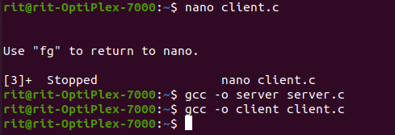

Running server in the background:

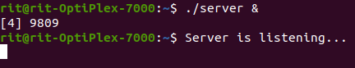

Uploding the file:

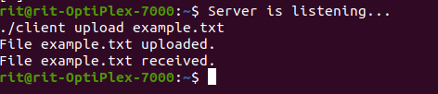

Downloading the file:

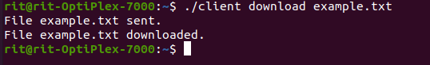

**Result:**

Thus the project done for creating a peer-to-peer file sharing application using IPC and program for this in C language. The above code for server and client was successfully executed.